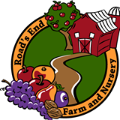
Road’s End Farm & Nursery
TheFruitGrowers.com
NMFruitGrowers@aol.com

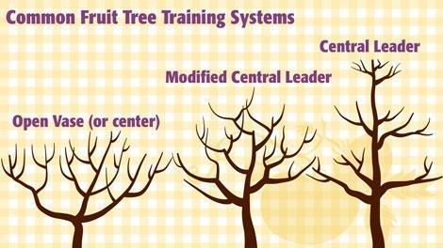
Pruning and training your fruit tree will improve it five ways:
* Keep it a manageable size
* Grow larger fruit
* Ensure a yearly crop
* Let light and air into the lower branches
* Renew the vigor of the tree
The three most popular shapes for fruit trees are Central Leader, Vase (or Open Center), and Modified Central Leader. Certain kinds of fruit trees are most productive with certain shapes. Some kinds of fruit trees can be trained in almost any way. We’ll show you the three shapes and list the trees that work best in that shape.

Central Leader training system
A Central Leader shape is a conical, “Christmas tree” that is tall and tapered. This shape gives the highest production, due to the light and air circulation, but it grows too tall to be practical for most home orchards. A home gardener can use this training system, though, when working with a dwarf tree.
A successful shape for: Apple, pear, persimmon, European plum & pecan trees.
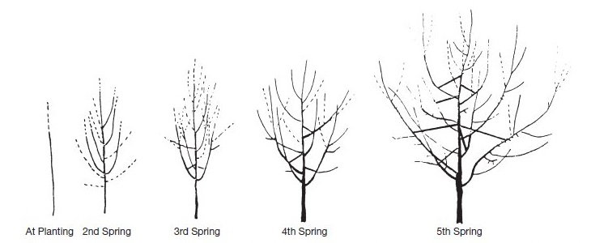
This diagram shows how to prune in the Central Leader system from planting through the fifth year.

Vase or Open Center training system
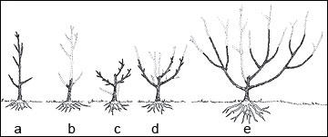
The Vase is the simplest shape for beginning orchardists to prune, and allows plentiful sunlight in its open center. The drawbacks are weak branches that need props when bearing fruit, and heavy shade that can develop from leaves on the upper branches of the tree.

A traditional shape for: Almond, apricot, cherry, fig, nectarine, peach, Japanese plum

Modified Central Leader training system
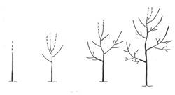
Modified Central Leader is the compromise shape. Here is a diagram of how to prune a tree according to this training system during its first four years
Combining the best features of both the Central Leader and Vase systems (sturdy trunk and central light) the Modified Central Leader is the default choice. Easier to harvest than a tall Central Leader tree, and with stronger branches than an Open tree, this is also the best choice for all fruit trees in the sunny Southwest.
A good choice for: Almond, apple, apricot, cherry, nectarine, pear, pecan, persimmon, E. plum

